Dear Travel Trade Partner,
During the passenger schedule change process for our Turkish Airlines flights, the following guidelines must be applied:

When the passenger is informed about a schedule change on their flight to IST or onward connections, they may either accept the offered alternative flight or exercise their right to a free reservation/rerouting change. This free reservation/rerouting change must be used once, within the ticket validity period, for a preferred date between -7/+30days. Such changes must be made to one of the 5 maximum airports listed in the table below.

For domestic tickets, cancellation penalties, and for international tickets, the reservation/rerouting change fee shall not be charged to the passenger during this process.

Example:

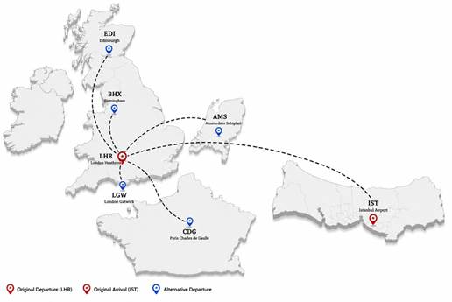

DESTINATION ON THE TICKET - AIRPORT | ALTERNATIVE DESTINATION - AIRPORT CODE
London Gatwick LGW | LGW, LHR, BHX, MAN, CDG, AMS
London Heathrow LHR | LHR, LGW, BHX, CDG, AMS, EDI
London Stansted STN | LHR, LGW, STN, BHX, MAN, CDG
Birmingham BHX | BHX, MAN, LHR, LGW, DUB, EDI
Edinburgh EDI | EDI, MAN, DUB, BHX, LHR, LGW
Manchester MAN | MAN, BHX, LHR, LGW, AMS, DUB

If you have any questions, please do not hesitate to contact us.

